**PROGRAM 3: SUPPLIER DATABASE**

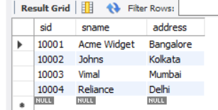 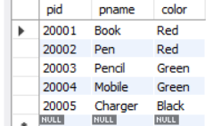 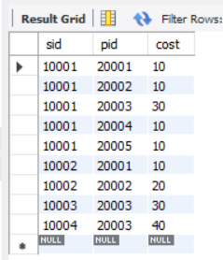

**QUERIES:**

**1**. Find the pnames of parts for which there is some supplier.

select pname,s.sname from Parts p,Catalog c,Suppliers s

where

c.sid in (select distinct sid from Suppliers) and

p.pid=c.pid and

c.sid=s.sid;

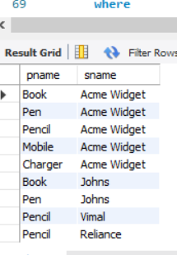

**2**. Find the snames of suppliers who supply every part.

select s.sname from Catalog c,Suppliers s

where

c.sid=s.sid

group by c.sid

having count(c.sid)=(select count(*) from Parts);

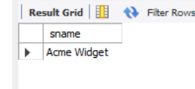

**3.** Find the snames of suppliers who supply every red part.

select s.sname,count(*) from Catalog c,Suppliers s,Parts p

where

c.sid=s.sid and

p.pid=c.pid and

c.pid in (

select c.pid from Catalog c,Parts p where c.pid=p.pid and

p.color="red"

group by c.pid)

group by s.sid

having count(*)=(

select count(*) from Parts where color="red" group

by color);

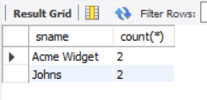

**4**. Find the pnames of parts supplied by Acme Widget Suppliers and by no one else.

select p.pname from Parts p,Suppliers s,Catalog c

where

s.sid=c.sid and

p.pid=c.pid and

s.sname="Acme Widget" and

c.pid not in (select c.pid from Catalog c,Suppliers s where s.sname <> "Acme Widget"and c.sid=s.sid)

group by c.pid;

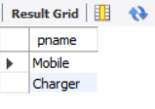

**5.**-- Find the sids of suppliers who charge more for some part than the average cost of that

-- part (averaged over all the suppliers who supply that part).

select sid from Catalog c1

where cost>(select avg(cost) from Catalog

where c1.pid=pid

group by pid)

;

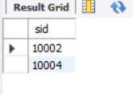

**6.** For each part, find the sname of the supplier who charges the most for that part.

select sid,pid from Catalog c1

where

cost=(select max(cost) from Catalog

where c1.pid=pid

group by pid)

;

